Assignment 2 :

1.List 3 real-world devices in your home or college that use SMPS (Switched Mode Power Supply) and 2 devices that use UPS (Uninterruptible Power Supply), explaining in one line why each device needs that type of power supply.
----
SMPS Devices--
- Desktop Computer – It uses an SMPS to convert electricity into the correct power needed by different computer parts.
- LED Monitor – It uses an SMPS to convert electricity into the lower voltage needed to run the monitor.
- Wi-Fi Router – It uses an SMPS to provide the correct power needed for the router to work.
UPS Devices--
- Desktop Computer – It uses a UPS to provide backup power when electricity goes off and prevent sudden shutdown.
- CCTV – It uses a UPS to keep the CCTV system working during a power cut.

2.Draw and label a diagram showing the main internal components of a typical SMPS unit found in a desktop PC, including AC input, rectifier, transformer, and DC output sections.<br><br><em><strong>Hint:</strong> You can hand-draw and upload a photo, or use any free diagram tool like draw.io.</em>
---
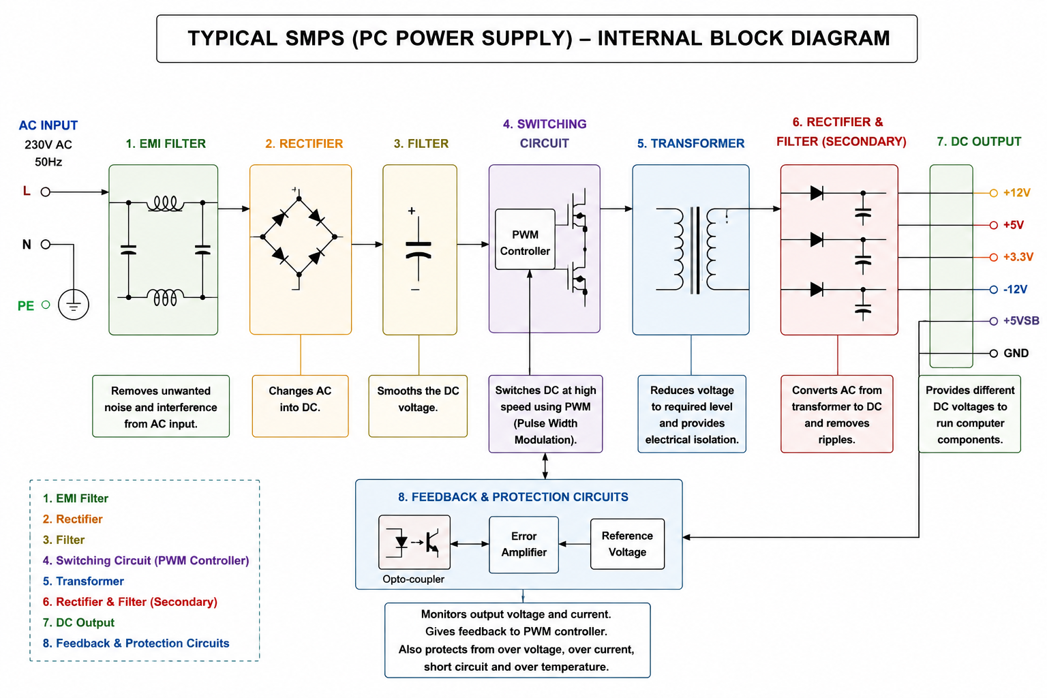

3.Take photos or find clear images online of the following power connectors: ATX 24-pin motherboard connector, SATA power connector, Molex connector, and PCle 6/8-pin connector. For each, write its name, the devices it powers, and one safety tip for connecting/disconnecting it.

1.ATX 24-Pin Motherboard Connector
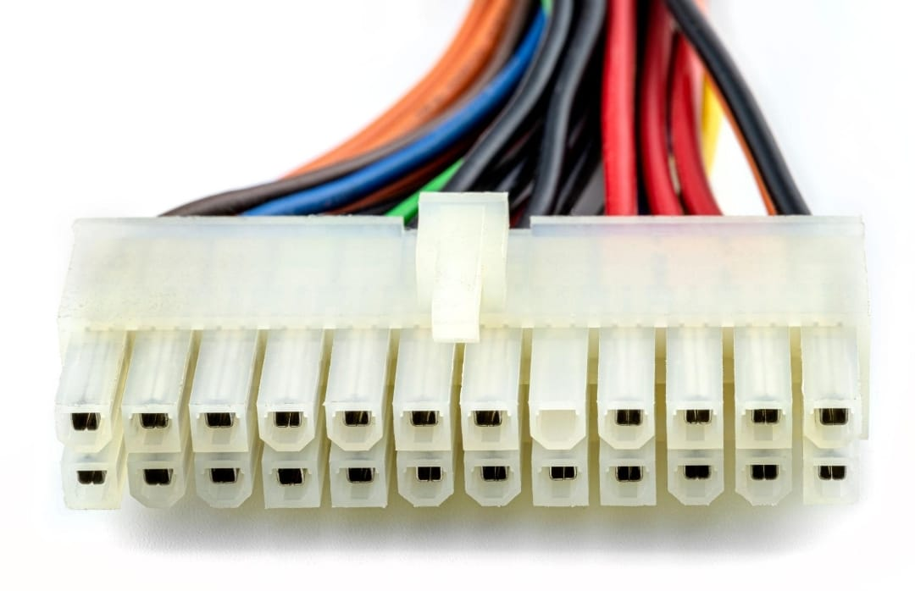

Powers: Motherboard and its main components.
Safety tip: Turn off and unplug the PC before connecting or removing it, and make sure the clip matches the socket.
2.SATA Power Connector
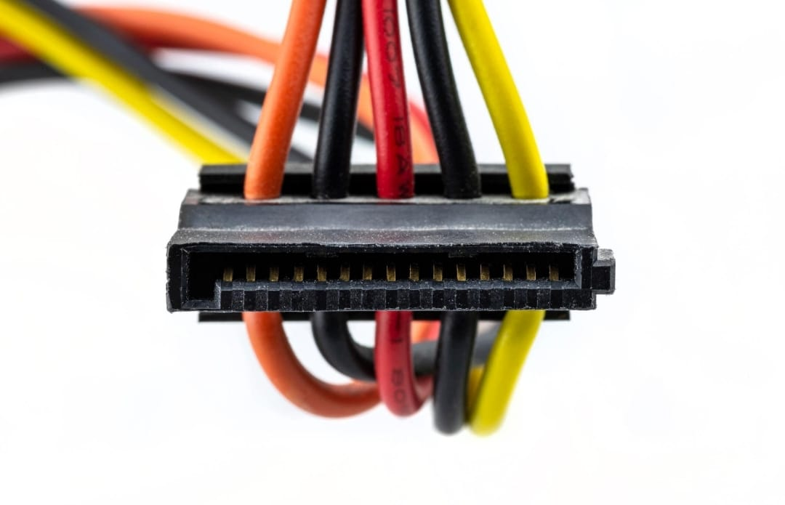

Powers: SATA HDDs, SSDs, optical drives, and some accessories such as fan/RGB controllers.
Safety tip: Do not force the connector; match its L-shaped shape with the device socket.
3.Molex Connector
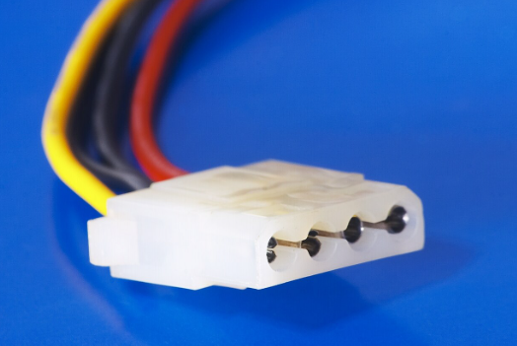
Powers: Older HDDs, optical drives, fans, and some older PC accessories.
Safety tip: Hold the plastic connector when removing it—do not pull the wires.
4.PCIe 6/8-Pin Connector
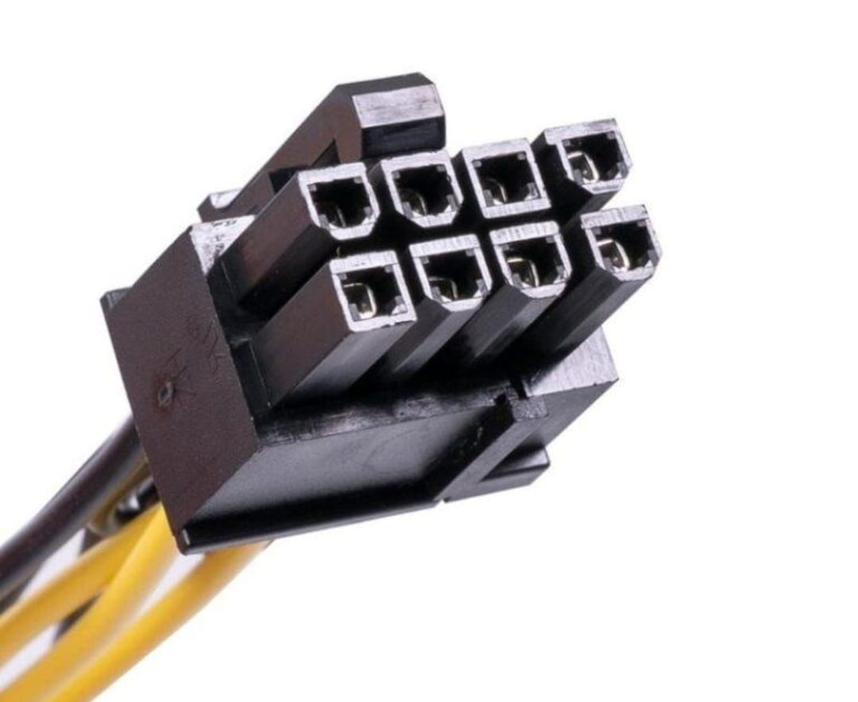

Powers: Dedicated graphics cards (GPU) that need extra power.
Safety tip: Make sure you use the PCIe cable, not the CPU/EPS cable, and push it in until it clicks.

4.Imagine you are setting up a new gaming PC. List the steps you would follow to connect the SMPS to the motherboard, graphics card, and storage devices, mentioning which specific cables and connectors are used for each.
---
Steps to Connect SMPS in a Gaming PC
- Turn off the PC and unplug it from the wall socket for safety.
- Connect the motherboard:
Connect the 24-pin ATX cable from the SMPS to the motherboard's 24-pin power connector.
- Connect the CPU:
Connect the 4/8-pin CPU (EPS) cable from the SMPS to the CPU power connector near the processor.
- Connect the graphics card:
Connect the 6-pin, 8-pin, or 6+2-pin PCIe power cable from the SMPS to the graphics card.
- Connect the SATA storage drive:
Connect the SATA power cable from the SMPS to the SATA HDD or SSD.
- Check all connections:
Make sure every connector is properly inserted and locked. Do not force any connector.
- Connect the SMPS to electricity:
Connect the SMPS power cord to the wall socket and switch on the PC.

